ASSIGNMENT NO. 6B
Title : Install and use CloudAnalyst.
Aim : Install a CloudAnalyst simulator tool and generate and study report of the simulation output.
Objective: To study different parameters passed to set up a cloud environment and how is it different from cloudsim. To compare reports generated by running different given scenarios.
Theory:
CloudAnalyst supports visual modelling and simulation of large-scale applications that are deployed on Cloud Infrastructures. CloudAnalyst, built on top of CloudSim, allows description of application workloads, including information of geographic location of users generating traffic and location of data centers, number of users and data centers, and number of resources in each data center. Using this information, CloudAnalyst generates information about response time of requests, processing time of requests, and other metrics. By using CloudAnalyst, application developers or designers are able to determine the best strategy for allocation of resources among available data centers, strategies for selecting data centers to serve specific requests, and costs related to such operations.
Feature of CloudAnalyst:
- Easy to use Graphical User Interface (GUI)- CloudAnalyst is equipped with an easy to use graphical user interface (see Figure 1) that enables users to set up experiments quickly and easily.

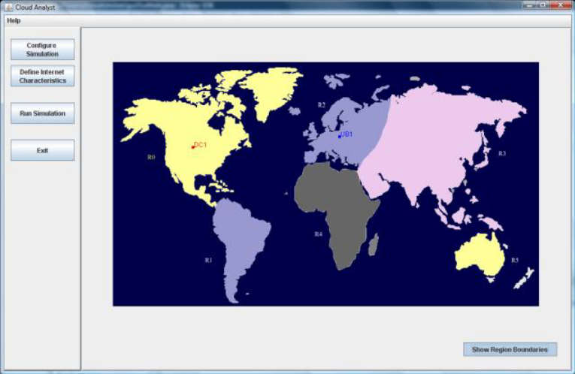
Figure 1: CloudAnalyst GUI
2. Ability to define a simulation with a high degree of configurability and flexibility- Simulation of complex systems such as Internet applications depends on many parameters. Typically, values for those parameters need to be arbitrarily assumed or determined through a process of trial and error. CloudAnalyst provides modelers with a high degree of control over the experiment, by modeling entities and configuration options such as: Data Center, whose hardware configuration is defined in terms of physical machines composed of processors, storage devices, memory and internal bandwidth; Data Center virtual machine specification in terms of memory, storage and bandwidth quota; Resource allocation policies for Data Centers (e.g., time-shared vs. space-shared); Users of the application as groups and their distribution both geographically and temporally; Internet dynamics with configuration options for network delays and available bandwidth; Service Broker Policies that control which segment of total user base is serviced by which Data Center at a given time; and simulation duration in minutes, hours or days.
3. Repeatability of experiments - CloudAnalyst allows modelers to save simulation experiments input parameters and results in the form of XML files so the experiments can be repeated. The underlying CloudSim simulation framework ensures that repeated experiments yield identical results.
4. Graphical output - CloudAnalyst is capable of generating graphical output of the simulation results in the form of tables and charts, which is desirable to effectively summarize the large amount of statistics that is collected during the simulation. Such an effective presentation helps in identifying the important patterns of the output parameters and helps in comparisons between related parameters. In the current version of CloudAnalyst, the following statistical metrics are produced as output of the simulation: Response time of the simulated application; overall average, minimum and maximum response time of all user requests simulated; Response time arranged by user groups, located within geographical regions; response time arranged by time, showing the pattern of changes in application usage during the day; usage patterns of the application; number of users arranged by time or regions of the world, and the overall effect of that usage on the data centers hosting the application; time taken by data centers to service a user request; overall request processing time for the entire simulation; average, minimum and maximum request processing time by each data center; response time variation pattern during the day as the load changes; and details of costs of the operation.
5. Use of consolidated technology and ease of extension- CloudAnalyst is based on a modular design that can be easily extended. It is developed using the following technologies: Java (the simulator is developed 100% on Java platform, using Java SE 1.6); Java Swing (the GUI component is built using Swing components); CloudSim (CloudSim features for modeling data centers is used in CloudAnalyst); and SimJava(some features of this tool are used directly in CloudAnalyst).
Architecture of CloudAnalyst-
As depicted in Figure 2, CloudAnalyst is built on top of CloudSim toolkit, by extending its functionalities with the introduction of concepts that model Internet and Internet application behaviour.
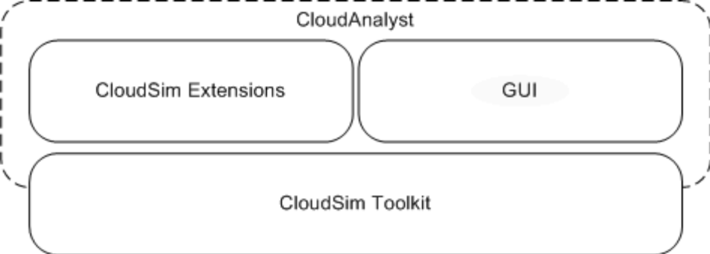
Figure 2: Architecture of CloudAnalyst

Design of CloudAnalyst Consists of Following Model-
GUI Package-
It is responsible for the graphical user interface, and acts as the front end controller for the application, managing screen transitions and other UI activities.

Simulation-
This component is responsible for holding the simulation parameters, creating and executing the simulation.

User Base-
This component models a group of users and generates traffic representing the users.

Data Center Controller-
This component controls the data center activities.

Internet-
This component models the Internet and implements the traffic routing behavior.

Internet Characteristics-
This is used to define the characteristics of the Internet applied during the simulation, including the latencies and available bandwidths between regions, the current traffic levels, and current performance level information for the data centers.

VM Load Balancer-
This component models the load balance policy used by data centers when serving allocation requests. Default load balancing policy uses a round robin algorithm, which allocates all incoming requests to the available virtual machines in round robin fashion without considering the current load on each virtual machine. Additionally, it is also offered a throttled load balancing policy that limits the number of requests being processed in each virtual machine to a throttling threshold. If requests are received causing this threshold to be exceeded in all available virtual machines, then the requests are queued until a virtual machine becomes available.

Cloud App Service Broker-
This component models the service brokers that handle traffic routing between user bases and data centers. The default routing policy routes traffic to the closest data center in terms of network latency from the source user base. In addition an experimental brokerage policy for peak load sharing is implemented on CloudAnalyst. This routing policy attempts to share the load of a data center with other data centers when the original data center’s performance degrades above a pre-defined threshold.

An important design decision we made was grouping simulation elements to improve the efficiency of simulation. In CloudAnalyst the events are grouped at three levels. In the first level, there are user bases, which represent a cluster of users which are handled as a single unit. In the next level, user requests generated from each regional user base are grouped based on a grouping factor, which is kept independent of the user base size. In the last level, requests simultaneously processed by a single virtual machine are grouped. The last two grouping factors are configurable by CloudAnalyst users, and it is also possible not to group simulation elements.
Scenarios for Cloud Analyst-
Scenario 1-Simple Web Application Hosted on a Single Data Center.
Like with most real-world web application let us assume initially the application is deployed in a single location, in Region 0 (North America).
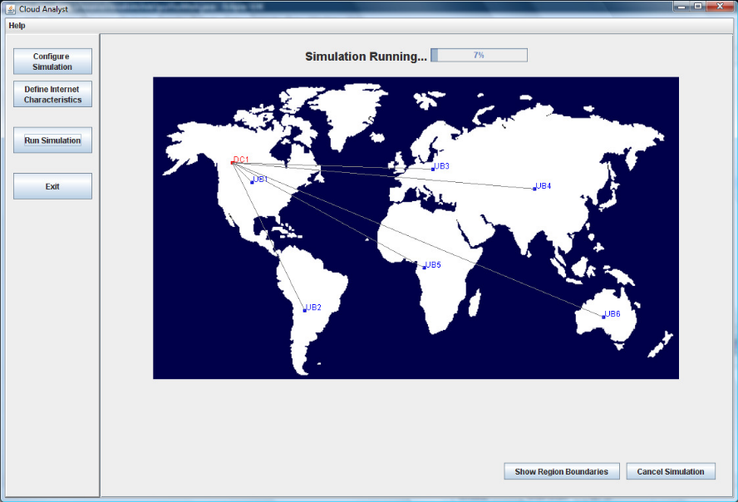
Figure. Scenario 1 - Single Data Center
Assuming the application is deployed in 50 virtual machines (with 1024Mb of memory in each VM running on physical processors capable of speeds of 100MIPS).
Cost is,
Total Virtual Machine Cost: $120.05
Total Data Transfer Cost: $512.74
Grand Total: $632.79

Scenario 2 – Web Application Hosted on Multiple Data Centers around the
World
When applications grow in popularity on the Internet the most common approach to improve service quality is to deploy the application in several locations around the globe. So for the second scenario, while keeping the user bases the same we add one more data center, in region 2 (Europe). To keep the cost the same the 50 virtual machines are allocated 25 in each data center.
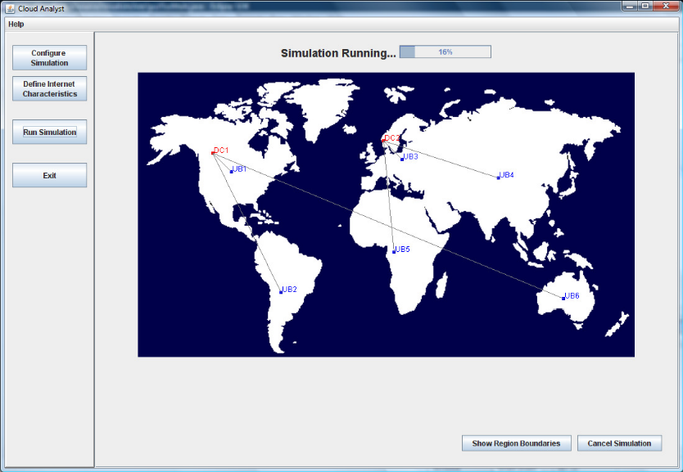
Figure- Scenario 2 - Application deployed in multiple Data Centers
Cost is,
Total Virtual Machine Cost: $120.05
Total Data Transfer Cost: $512.74
Grand Total: $632.79
Same as of scenario 1.
But if data centre is loading with 50vms in each data centre then cost is increased
Total Virtual Machine Cost: $ 240.10
Total Data Transfer Cost: $ 512.74
Grand Total: $ 752.84
Scenario 3 – Dynamic Re-Configuration of the Web Application Deployment
Based on Usage
Based on the observations so far, the optimal solution looks to be a setup where the resources are dynamically allocated depending on the current work load. E.g. the highest load from region 0 (N. America) occurs from 13:00-15:00 GMT and during this time the data center servicing these requests (usually the data center located in region 0 itself) should have a higher number of VMs allocated. But once the peak has passed, the number of VM’s could be dynamically reduced and the number in a different data center facing higher load can be
increased.
Mathematical Model:

M = {I, O, Fn, Sc, Fc}

I = Input.
I = {I1, I2, I3, I4, I5}
Where I1 = User base configurations.
I2 = Data centre configurations.
I3 = Internet characteristics.
I4 = Service broker policy.
I5 = Load balancing policy.

O = Output.
O = {O1, O2, O3}
Where O1 = Cloud Simulation.
O2 = Response time summary.
O3 = Total cost.

Fn = Functions.
Fn = {Fn1, Fn2, Fn3, Fn4}
Where Fn1 = Create Datacentres.
Fn2 = Create Broker.
Fn3 = Create Virtual Machines.
Fn4 = Start Simulation

Sc = Success cases.
Sc = {Sc1, Sc2}
Where Sc1 = Cloud simulation is successful.
Sc2 = Data centres and virtual machines are created properly.

Fc = Failure cases.
Fc = {Fc1, Fc2}
Where Fc1 = Cloud simulation is unsuccessful.
Fc2 = Data centres and virtual machines are not created properly.
Input :
- Parameters for Virtual Machine.
- Characteristics of a data center.

Output : Output of simulation in pdf format.

Platform : Ubuntu 12.04 , Jdk1.7
Conclusion : Reports are generated for above given scenario.

